Create the following table structure in SNOWFLAKE by creating your own warehouse. Insert some 10 rows using INSERT command (check task 3 and same way insert for all task tables) in the table by trying different values for all the columns and then check using SELECT *

Once data is loaded, performed the below task

**Task 1:**

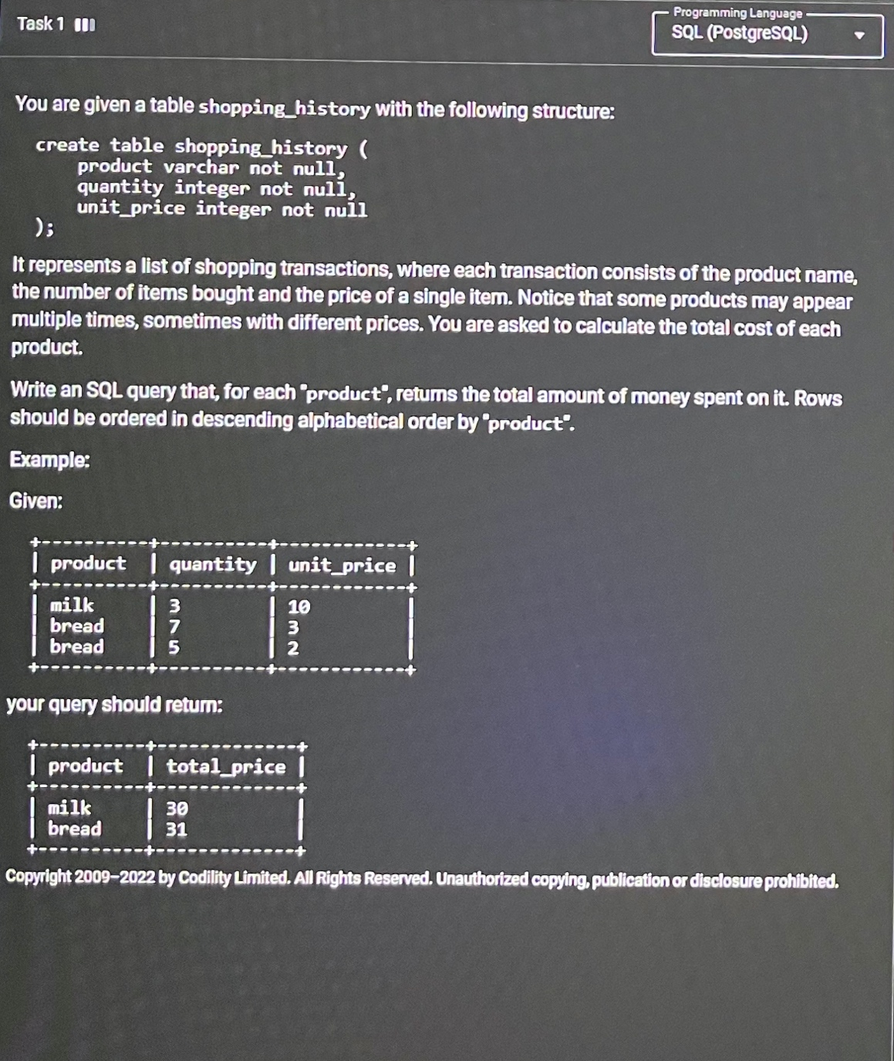

Ans:

select product,

quantity*unit_price as Total_Price

from shopping_history

group by product

order by total_price desc;

**Task 2:**

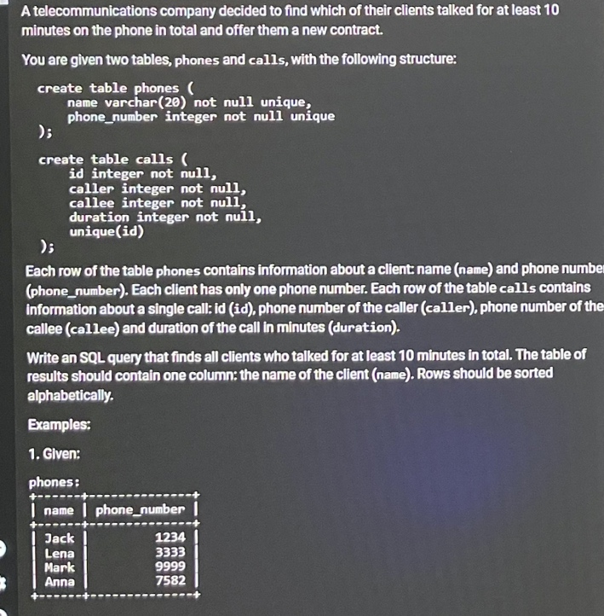 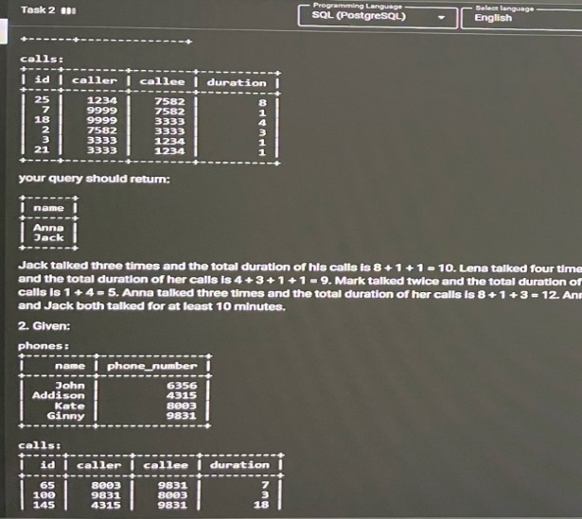

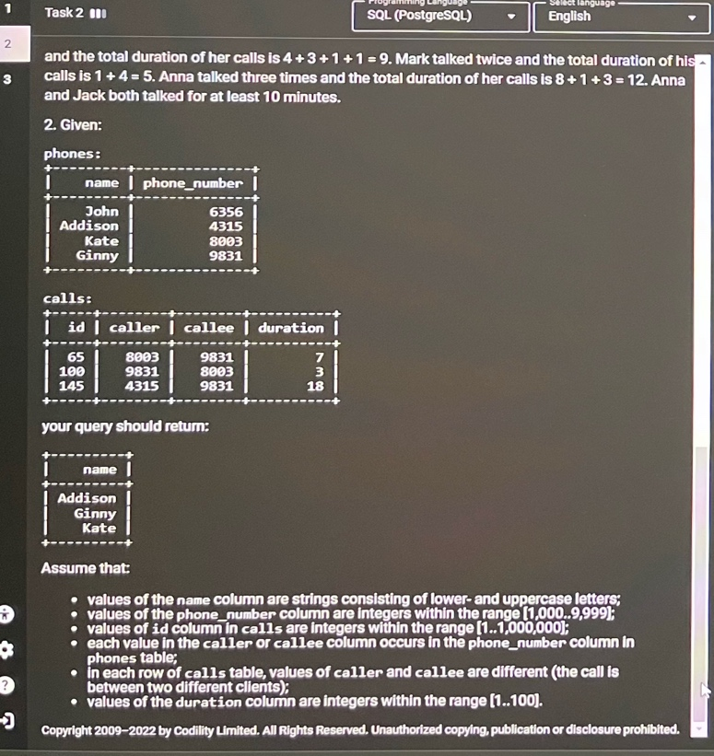

**Ans:**

**with call_duration as (**

**select caller as phone_number, sum(duration) as duration from calls group by caller**

**union all**

**select callee as phone_number, sum(duration) as duration from calls group by callee**

**)**

**SELECT name**

**FROM phones p join call_duration cd on cd.phone_number = p.phone_number**

**GROUP BY name**

**HAVING SUM(duration) >= 10**

**ORDER BY name**

**Task 3:** **Output display is just one column balance**

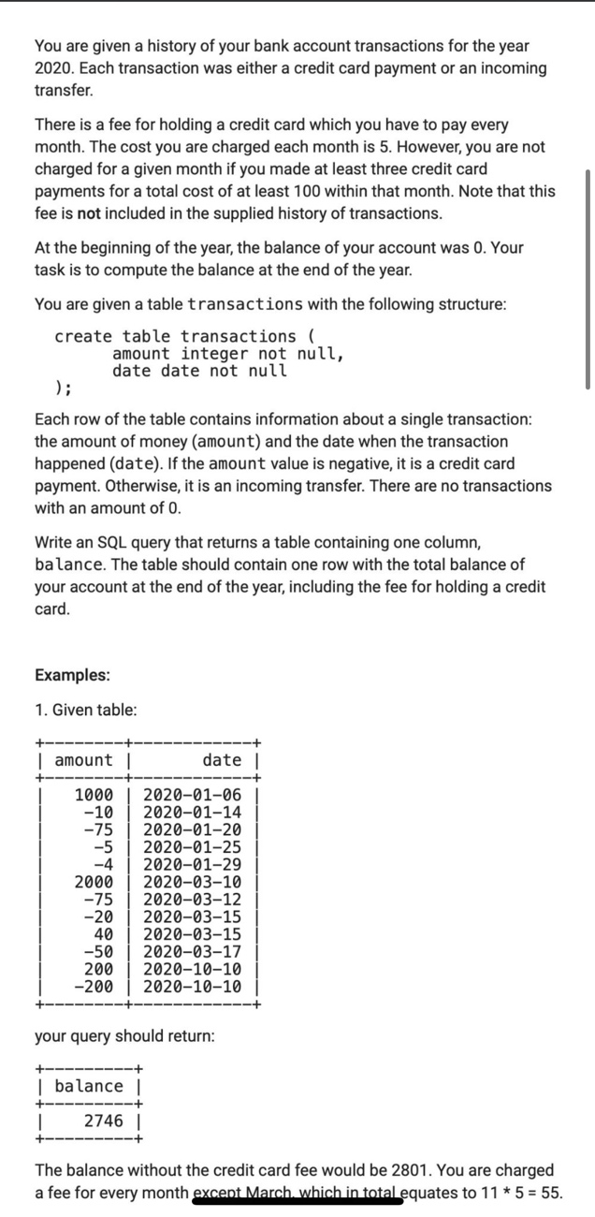 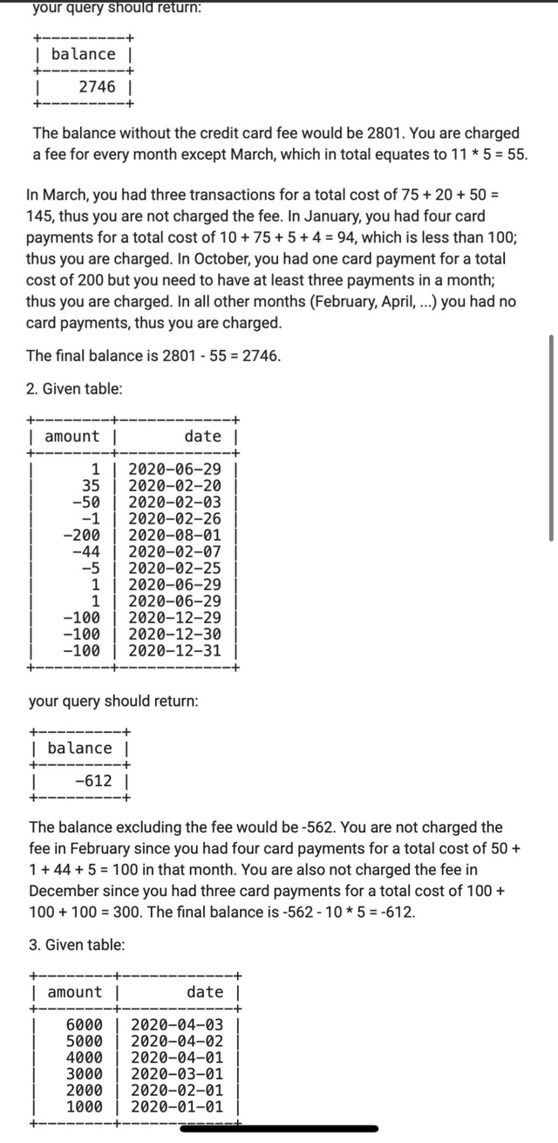

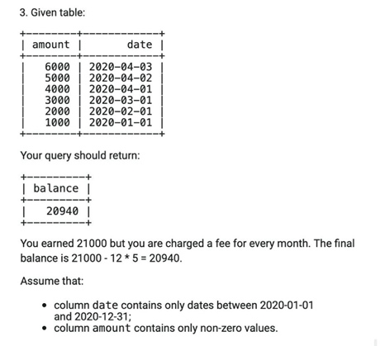

You can add the following data in the table

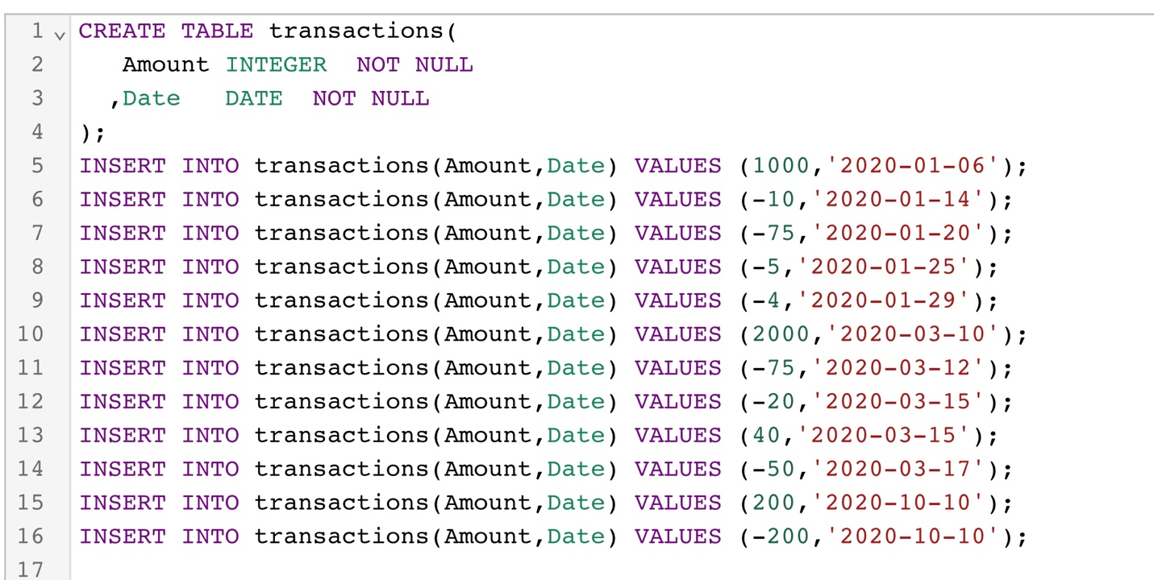

Select ( sum(a.total) - (12- count(b.cnt ))*5 ) as result From

(Select sum(amount) as total , 'A' as name from transactions ) as a left join

(Select count(amount) as cnt , 'A' as name

From transactions

where amount <0

group by month(date)

having not(count(amount) <3 or sum(amount) >-100) ) as b

on a.name = b.name